Screenshot of queries and output: command prompt 1) question:

Create Database:

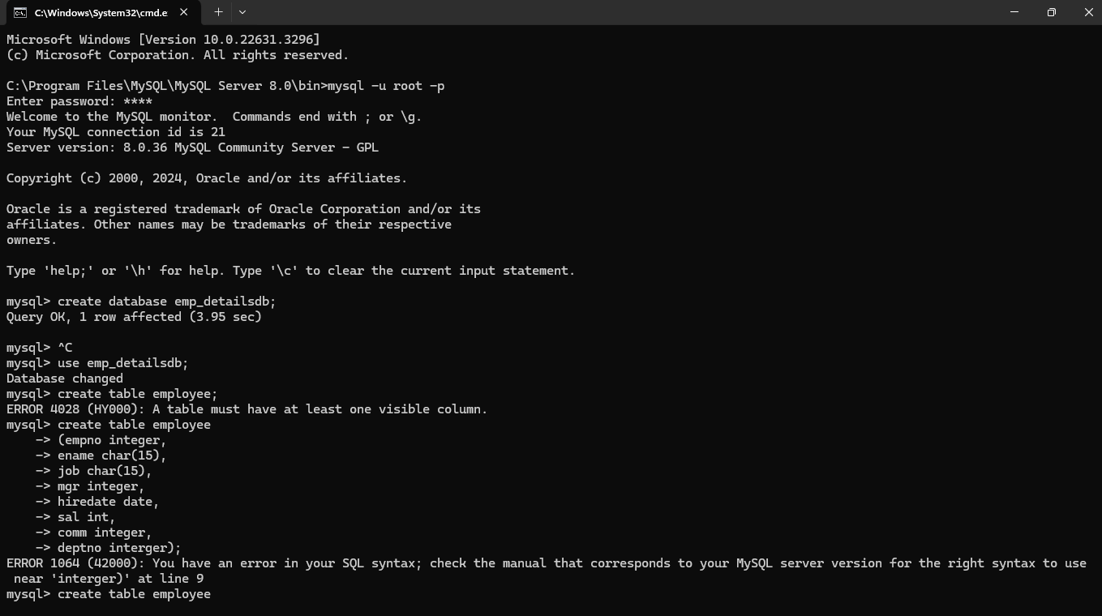

Structure of table:

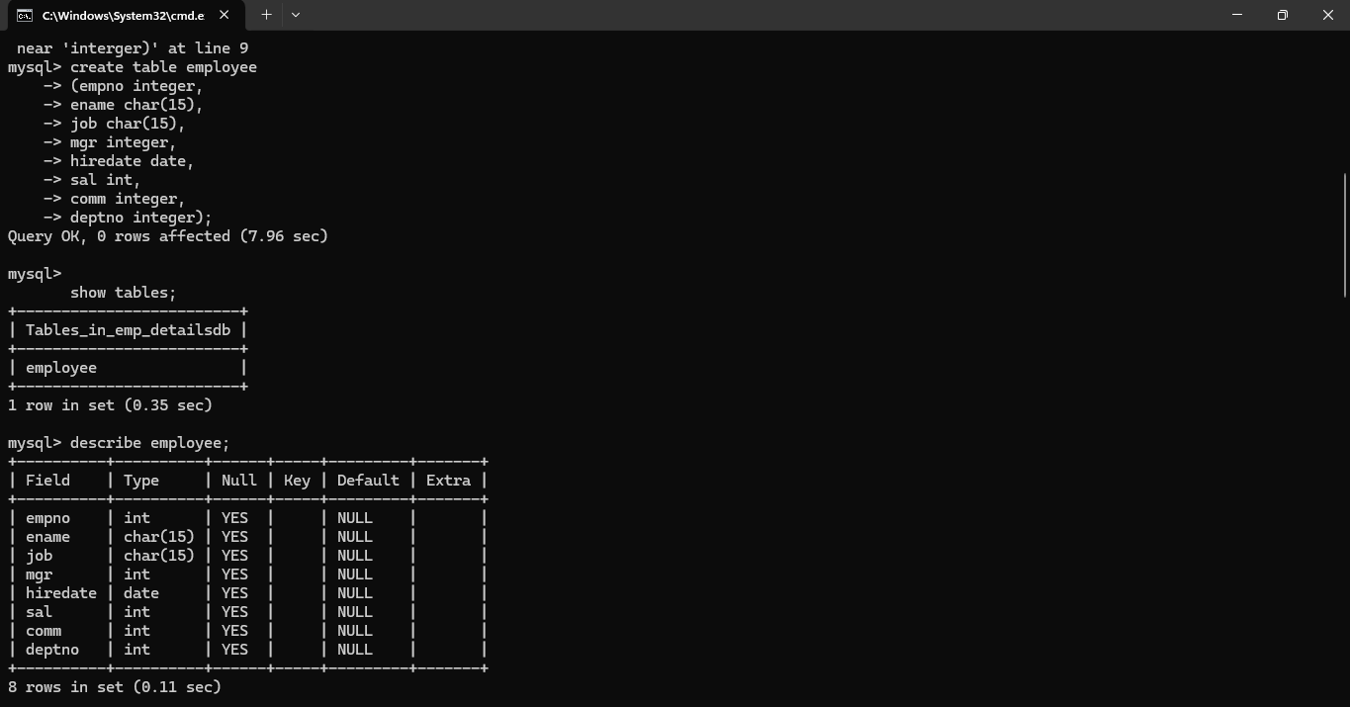

Insert into table:

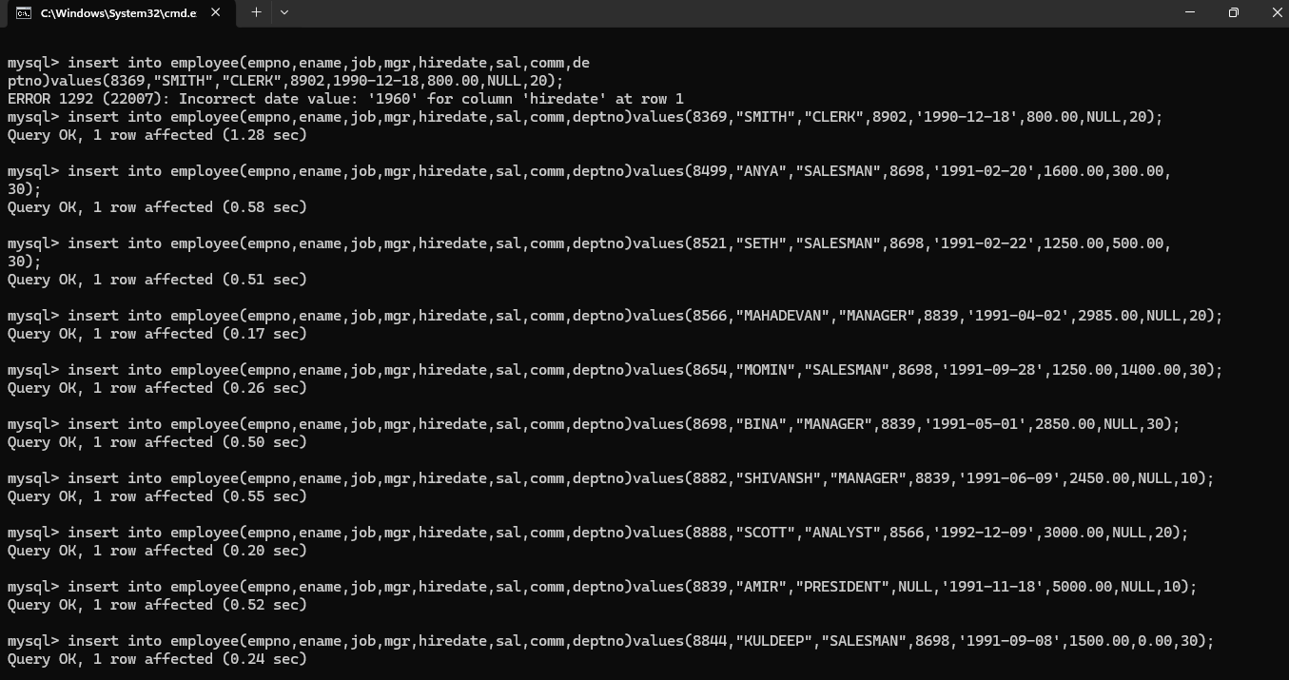

Employee table:

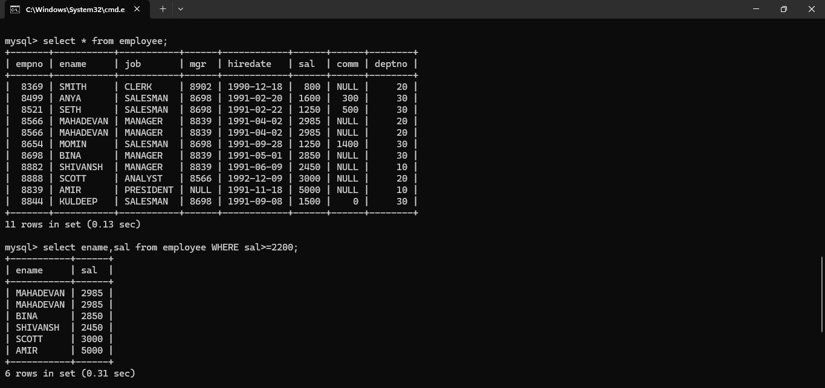

1. A:

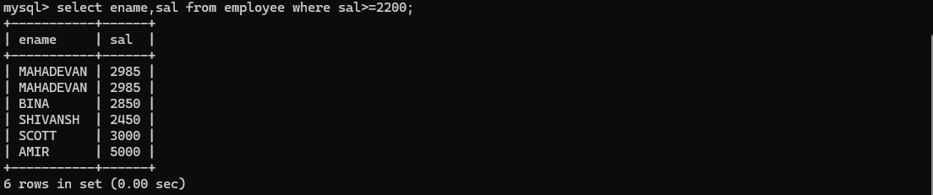

B:

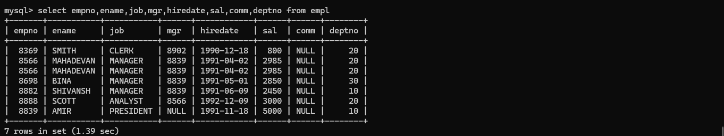

C:

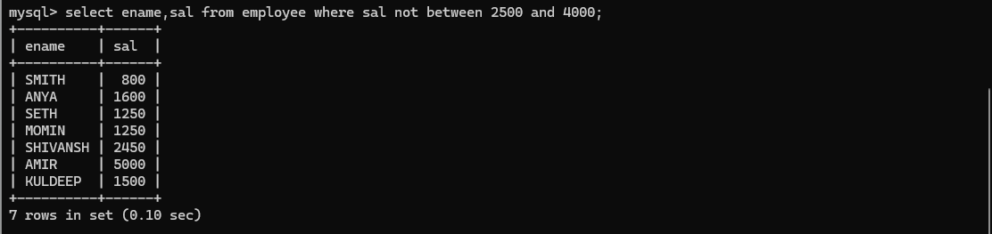

D:

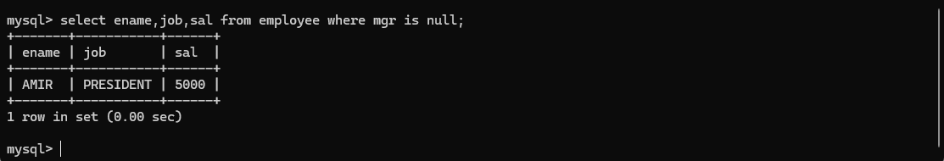

E:



F:

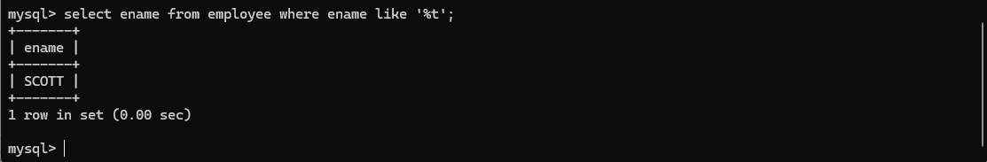

1. JDBC output:

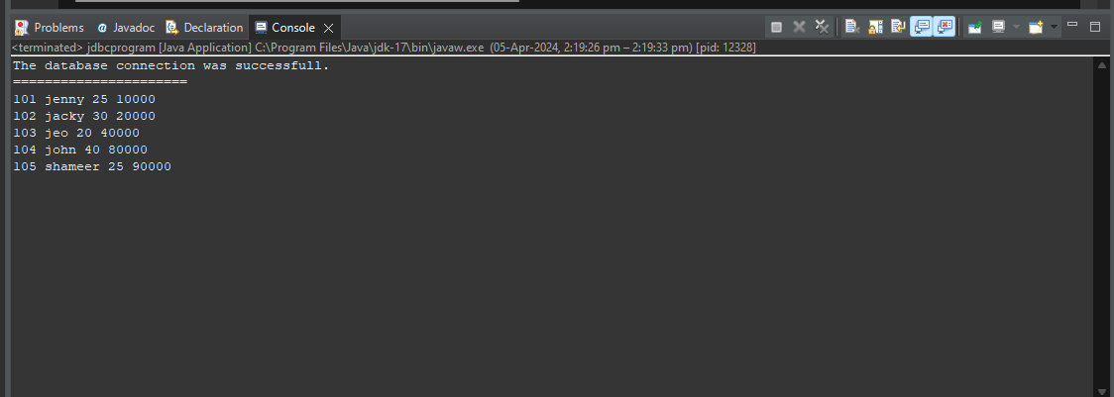

Backend output:

